HDR Links, Forms and Resources Cheat Sheet September 2026 – Graduate Research School
1. Graduate Research School website
- Direct link to the GRS website: Graduate Research School - JCU Australia
- Information on Thesis Submission and Examination: My Thesis
- Information on Milestones: My Milestones
- Seminar Advertisements Calendar - found on the GRS main page below (red box)
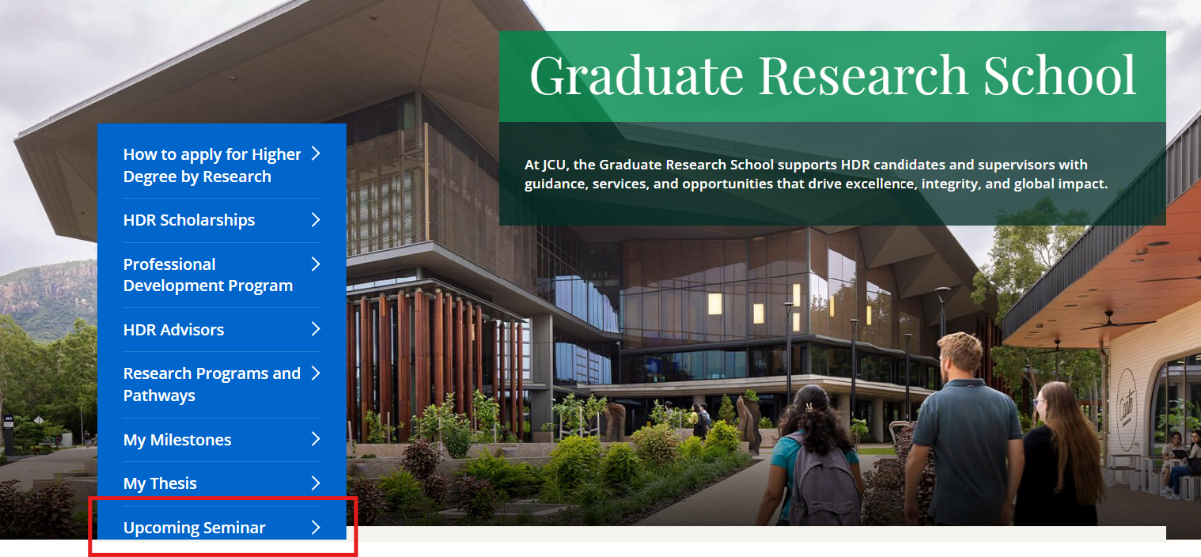
2. SharePoint Resources for Advisors and ADREs
Information for advisors on milestones (including seminar bookings), thesis submission, and Nomination of Examiner processes. Guides and Resources for Advisors and ADREs
3. HDR Information Portal (for candidates)
Seminar advertisements found under ‘HDR Seminar Spotlight’ in the HDR Information Portal. HDR Information Portal
4. Accessing digital forms – CiAnywhere and MyStudent
CiAnywhere is where Advisors and ADREs access various digital forms for processing. It is a system used across the University and houses the HDR forms.
- CiaAnywhere (accessible by advisors and ADREs only): Log On - CiA
- MyStudent (accessible by candidates only): Log On - MyStudent
NOTE: CiAnywhere is the staff-facing version of the portal, MyStudent is the student-facing version of the portal. They are the same portal.
Staff-Student status: If you are a staff member who previously or currently holds student status at JCU, you may encounter issues with the CiAnywhere/MyStudent portal. Please submit a ServiceNow request to IT for assistance.
5. ServiceNow (for IT Support): ServiceNow
6. New digital forms (replacing all previous paper forms):
- Confirmation of Candidature Form (submitted by candidate first in MyStudent): COC Form
- Mid-Candidature Form (submitted by Primary Advisor first in CiAnywhere): MCR Form
- Pre-Completion Form (submitted by Primary Advisor first in CiAnywhere): PCE Form
- Nomination of Examiners Form (submitted by Primary Advisor following Pre-Completion, in CiAnywhere): NoE Form
- Thesis Submission Form (submitted by candidate first in MyStudent): Thesis Submission Form
7. Other digital forms (in place since March 2026)
- Variation of Candidature forms (submitted by Candidate first in MyStudent): https://www.jcu.edu.au/graduate-research-school/doctor-of-philosophy-candidates/variation-of-candidature
- Seminar Request Form (submitted by Candidate first in MyStudent): Seminar Request Form

